**Excel Assignment - 17**

**1. What are modules in VBA and describe in detail the importance of**

**creating a module?**

A *module*is the fundamental syntactic unit of VBA source code. The physical representation of a *module* is implementation dependent but logically a VBA *module* is a sequence of Unicode characters that conform to the VBA language grammars.

A module consists of two parts: a *module header* and a *module body*.

The *module header* is a set of *attributes* consisting of name/value pairs that specify the certain linguistic characteristics of a *module*.

A *module body* consists of actual VBA Language source code and most typically is directly written by a human programmer.

**2. What is Class Module and what is the difference between a Class**

**Module and a Module?**

**Class modules** are special modules that can help us create our own custom objects. We can also define methods, properties, and events for those objects. And when we create a new object from the class module, we can refer to it from the standard module as well.

The main difference between classes and modules is that classes can be instantiated as objects while standard modules cannot.

**3. What are Procedures? What is a Function Procedure and a Property**

**Procedure?**

A *procedure* is a block of Visual Basic statements enclosed by a declaration statement (Function, Sub, Operator, Get, Set) and a matching End declaration. All executable statements in Visual Basic must be within some procedure.

Function Procedure return a value to the calling code. They can perform other actions before returning.

Property Procedure return and assign values of properties on objects or modules.

**4. What are Procedures? What is a Function Procedure and a Property**

**Procedure?**

Same as 3rd.

**5. What is a sub procedure and what are all the parts of a sub procedure**

**and when are they used?**

A Sub procedure is a series of Visual Basic statements enclosed by the Sub and End Sub statements. The Sub procedure performs a task and then returns control to the calling code, but it does not return a value to the calling code.

You can define a Sub procedure in modules, classes, and structures. By default, it is Public, which means you can call it from anywhere in your application that has access to the module, class, or structure in which you defined it.

A Sub procedure can take arguments, such as constants, variables, or expressions, which are passed to it by the calling code.

The syntax for declaring a Sub procedure is as follows:

[modifiers] Sub SubName[(parameterList)]

' Statements of the Sub procedure.

End Sub

The modifiers can specify access level and information about overloading, overriding, sharing, and shadowing.

A sub procedure is usually used to accept input from the user, display information, print information, manipulate properties or perform some other tasks. It is a program code by itself and it is not an event procedure because it is not associated with a runtime procedure.

**6. How do you add comments in a VBA code? How do you add multiple**

**lines of comments in a VBA code?**

Adding comment on a single line

1. First, click on the line where you want to insert the comment.
2. After that, type an APOSTROPHE using your keyboard key.
3. Next, type the comment that you want to add to the code.
4. In the end, hit enter to move to the new line and the comment will turn green.

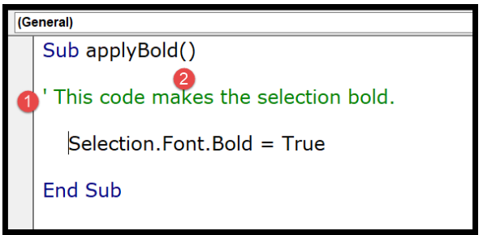

**Adding comment on multiple line**

Select all the lines and then use the comment button from the toolbar or you can also add an APOSTROPHE at the starting of each line.

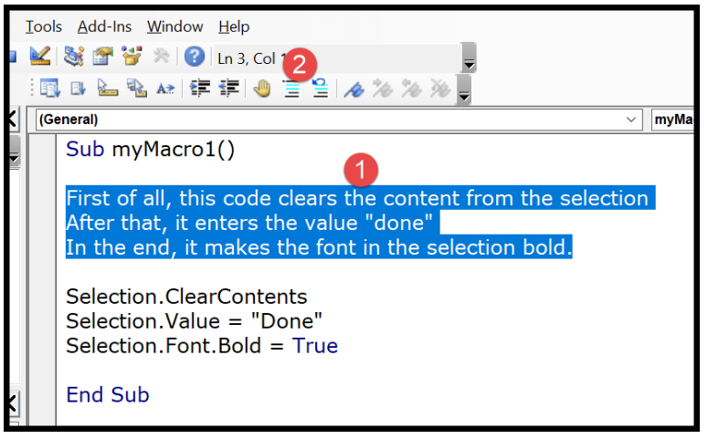

**7. How do you add comments in a VBA code? How do you add multiple**

**lines of comments in a VBA code?**

**Same as 6th one.**